1. Agenda:
   1. We will run the app to see sending and receiving a msg in action.
2. Mentor pointed to some configuration places which were handled wrongly by name and made us correct them.
3. 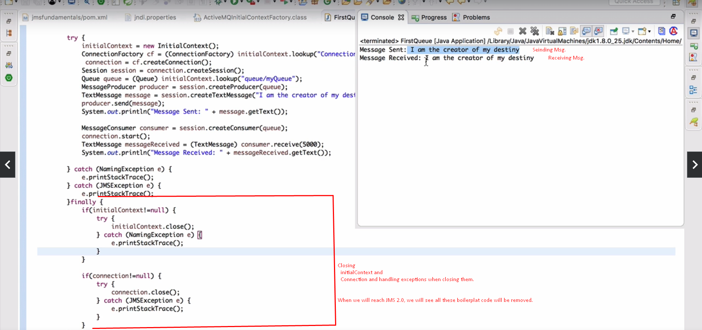
4. Mentor: We put Producer and Consumer code in the same file and in the same project but in real time application, we have separate code.